Cover letter

December 26, 2007
Editorial Department of Asian Journal Pharmaceutical Sciences
Shenyang Pharmaceutical University
No.103, Wenhua Road, Shengyang 110016, China

Dear Editor of AJPS,
I am submitting a manuscript for consideration of publication in Asian Journal of Pharmaceutical Sciences. The manuscript is entitled “Preparation of nimodipine microspheres contained in a solid dispersion and evaluation of their in vitro and in vivo characteristics”.
It has not been published elsewhere and that it has not been submitted simultaneously for publication elsewhere.
Nimodipine was formulated into immediate and sustained release microspheres in a solid dispersion. Two types of microspheres i.e. immediate release and sustained release microspheres could be successfully prepared through adjustment of the ratio of nimodipine to the functional additives. Following X-ray, DTA and SEM analysis, it was found that nimodipine was highly dispersed and present in the microspheres in an amorphous state.
Thank you very much for your consideration.
Yours Sincerely,
Prof. Hua Zhang
Shenyang Pharmaceutical University
No. 103 Wenhua Road, Shenyang 110016, China
Tel.: +86-24-23986251; Fax: +86-24-23986253
E-mail: zhhundds@163.com
Graphical Abstract

Preparation of nimodipine microspheres contained in a solid dispersion by the emulsion-solvent-diffusion method and evaluation of their in vitro and in vivo characteristics

Hua Zhang^{a,}*, Xu Wangª, Min Yangª, Y. Kawash^{b}
ªShenyang Pharmaceutical University, No.103, Wenhua Road, Shenyang 110016, China
^{b}Gifu Pharmaceutical University, 5-6-1 Mitahora-higashi, Gifu 502, Japan

Raspberry-like assembly of nanogels was prepared by Michael addition of acrylate-modified cholesterol-bearing pullulan nanogel and thiol-modified poly (ethylene glycol) cross-linker. Interleukin 12, an immunostimulatory cytokine, is encapsulated and released over a prolonged period of time both in vitro and in vivo.

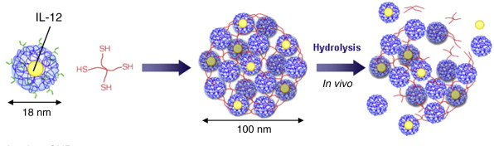

Title page

Preparation of nimodipine microspheres contained in a solid dispersion by the emulsion-solvent-diffusion method and evaluation of their in vitro and in vivo characteristics

Hua Zhang^{a,}*, Xu Wangª, Min Yangª, Y. Kawash^{b}
ªShenyang Pharmaceutical University, No.103, Wenhua Road, Shenyang 110016, China
^{b}Gifu Pharmaceutical University, 5-6-1 Mitahora-higashi, Gifu 502, Japan

Corresponding author:
Corresponding author: Hua Zhang*
Mailing address: Shenyang Pharmaceutical University, No.103, Wenhua Road, Shenyang 110016, China
Tel.: +86-24-23986353; Fax: +86-24-23986355
Mobile phone: 13………..
E-mail: zhhundds@163.com

Abstract:

To prepare nimodipine immediate and sustained release microspheres in a solid dispersion by the emulsion-solvent-diffusion method in a single step. Special attention was devoted to improving the dissolution rate of the drug and then the controlled release of drug from the microspheres. Eu E100 and Aerosil were employed as a solid dispersion base for the immediate release microspheres, while HP55 and aerosil were employed as a solid dispersion base for the sustained release microspheres, while ethyl cellulose (EC) was selected as a retarding agent to control the drug release rate. Micromeritic properties of the microspheres, the drug dispersion state and the drug release profiles of the microspheres were investigated. Relative bioavailabilities of two types of microspheres were compared with NimotopTM, a commercial nimodipine tablet, in a study in 3 healthy dogs. Two types of microspheres i.e. immediate release and sustained release microspheres could be successfully prepared through adjustment of the ratio of nimodipine to the functional additives. The particle size of the resultant microspheres was mainly controlled by the agitation speed during the manufacturing process. Following X-ray, DTA and SEM analysis, it was found that nimodipine was highly dispersed and present in the microspheres in an amorphous state. The drug release rate from the microspheres was very dependent on the type and amount of the functional additives in the formulation. The relative bioavailabilities of the immediate release microspheres and sustained release microspheres, compared with the NimotopTM tablet, were 118.2% and 96.1%, respectively. The emulsion-solvent-diffusion method is a simple and efficient technique for designing functional microspheres for poorly water-soluble drugs.

Keywords: Nimodipine; Solid dispersion; Microsphere; Sustained release

1. Introduction

Solid dispersion is one of the most efficient techniques to improve the dissolution rate of poorly water-soluble drugs, leading to an improvement in the relative bioavailability of their formulations. At present, the solvent method and the melting method are widely used in the preparation of solid dispersions. In general, subsequent grinding, sieving, mixing and granulation are necessary to produce the different desired formulations.
The spherical crystallization technique is a novel agglomeration method performed in a liquid system which was developed by Kawashima in the 1980s [1]. In this system, agglomeration and spheroidization can be carried out simultaneously during the crystallization process of a substance with a bridging liquid by means of stirring. In the beginning, the spherical crystallization technique was mainly used in direct tabletting technology, because crystallization and agglomeration could be carried out simultaneously in a single step. The resultant agglomerates produced exhibited dramatically improved flowability, packability and compressibility [2, 3]. Later on, functional drug devices such as microspheres [4], microcapsules [5], microballoons [6], and biodegradable nanospheres [7] were developed using the emulsion-solvent-diffusion method, one of the spherical crystallization techniques involving the introduction of a functional polymer into the system. In previous studies we have designed sustained release mirospheres for a water soluble drug [8], a water insoluble drug [9] and an oily drug [10] using this technique.

2. Materials and methods

2.1. Materials

Nimodipine (Shandong Xinhua Pharmaceutical Co. Ltd. China) was used as a model drug，Eudragit E (Eu E100, Röhm Pharma, Germany) and hydroxypropylmethylcellulose phthalate (HPMCP, Shinetsu Chemical Co. Ltd. Japan) were selected as a dispersion base, aerosol (pass 400 mesh, Qingdao Ocean Chemical Co. Ltd. China) as a absorbent was added to promote drug dispersion and increase the mass for compact consolidation of the resultant microspheres. Ethylcellulose (EC 10 cp, Shanghai Colorcon Co. Ltd. China) was used as a retarding agent to control the drug release. Acetone was selected as a good solvent, distilled water was used as a poor solvent, and dichloromethane (Shenyang Chemical Co. Ltd.) was chosen as a bridging agent due to its good wettability with regard to both the drug and polymers, and its immisciblity with the poor solvent. A small amount of surfactant, such as poloxamer (F188, Shenyang Pharmaceutical Factory, China), was added to the poor solvent in order prevent sticking to the baffle or the agitator. NimotopTM (Bayer com., Germany) was selected as a reference formulation for the relative bioavailability test. All solvents used were of analytical grade.

2.2. Preparation of immediate release microspheres of nomodipine

Nimodipine (0.6 g) and Eu E100 (1.2, 2.4 and 3.6 g) were dissolved in a mixture of good solvent (acetone, 10 ml) and bridging liquid (dichloromethane, 2.5 ml), and the dispersion agent (aerosol, 1.2, 2.4 and 3.6 ml) was added to the drug-polymer solution system. The poor solvent (distilled water, 150 ml) containing poloxamer (4%, 3 ml) was placed in a 500 ml flask fitted with three baffles to improve agitation during the agglomeration process. When the drug-polymer solution was added to the poor solvent at a temperature of 25°C and 400–600 r/min stirring with a propeller type agitator, the drug-polymer solution immediately dispersed as droplets to form a quasi o/w emulsion, and the emulsion droplets gradually solidified along with the diffusion of the good solvent from the droplets into the poor solvent. Finally, the coprecipitated microspheres of the drug-polymer were filtered and dried in oven at 50°C for more than 6 h to reduce the residual solvent in accord with the tolerance given in Ch.P.

2.3. Preparation of sustained release microspheres of nimodipine

In the preparation of the sustained release microspheres, the process and the equipment was the same as that used for the immediate release microspheres. The formulations were as follows: Nimodipine: HP55: aerosol: EC = 1: 2: 7: (0.5, 0.625 and 0.75) were dissolved in the mixture of good solvent (acetone, 11 ml) and bridging liquid (dichloromethane, 7 ml), then the drug-polymer solution was poured into the poor solvent (distilled water, 200 ml) with the temperature controlled at 15–20 °C under stirring at 700 r/min. After agitating the system for 20–40 min, the emulsion droplets gradually solidified through coacervated droplets, and the resulting microspheres were filtered and dried using the same method as for the immediate release microspheres.

3. Results and discussion

3.1. Preparation mechanism

In this study, acetone and dichloromethane, in which nimodipine is readily soluble, were used as a good solvent and bridge liquid to dissolve the drug and pH- dependent polymers, and distilled water containing 4% (w/v) poloxamer was used as a poor solvent to precipitate both nimodipine and the pH-dependent polymers. Gradually, the emulsion droplets solidified along with diffusion of the good solvent, e.g., drug and polymers were coprecipitated in the droplets, leading to the formation of microspheres, i.e., dichloromethane as the bridging liquid was commixed with the good solvent, and when the good solvent in the droplets diffused into the poor solvent, the residual dichloromethane in the droplets bridged the aerosil, coprecipitated drug and polymer to form agglomerates. The aerosil acts as a dispersing agent and mass compactor, because coacervation droplets formed from the drug-polymer droplets during the solidifying period were very sticky and readily coalesced, while the introduction of Aerosil efficiently prevented coalescence and produced compact microspheres. In addition, the aerosol also dramatically improved the drug dispersion, resulting in the formation of a solid dispersion.

3.2. Micromeritic properties of the microspheres

As discussed above, the mean particle size (D₅₀) or size distribution of the microspheres was mainly controlled by the agitation speed. The average diameter of the microspheres was controlled mainly by the agitation speed during the formation of quasi-emulsion droplets during the initial stage. Fig. 2 shows the change in the D₅₀ of the microspheres with regard to the stirring speed, i.e., increasing the agitation speed reduced the particle size. It was found that the temperature of the solvent system also affected the properties of the resulting microspheres. Increasing the temperature of the liquid system resulted in a reduction in particle size, and tended increase the sphericity. In this study, under the optimum conditions for producing immediate release microspheres, which were determined by the orthogonal design method, the total recovery was 97%. The micromeritic properties of the resultant microspheres are shown in Table 1.

4. Conclusion

By combination of a polymeric crystallization technique and a solid dispersion technique, the immediate and sustained release microspheres could be successfully produced in a solid dispersion state. Aerosil as a drug dispersion agent and fillers helped prevent the coalescence of sticky polymer droplets during the preparation process, the method was highly reproducible and offered a high recovery.

Declaration of interest

The authors report no conflicts of interest. The authors alone are responsible for the content and writing of this article.

Acknowledgements

The authors acknowledge the financial support received from Council for Technical Education (CTE), for their support and encouragement in carrying out his college work.
References

- Francis MF, Lavoie L, Winnik FM, Leroux JC. Solubilization of cyclosporine A in dextran-g-polyethyleneglycolalkylether polymeric micelles. Eur J Pharm Biopharm 2003;56(3):337-46.
- Joshi R, Feldmann V, Koestner W, Detje C, Gottschalk S, Mayer HA, et al. Multifunctional silica nanoparticles for optical and magnetic resonance imaging. Biol Chem 2013;394(8):125-35.

Figure and Table legends

Fig. 1. Effect of tablet geometry on drug release.
Fig. 2. Pathological features of specimens of the: (A) anterior mediastinum and (B) hepatic tumors demonstrate similar morphology as described in the text. (C, D) he key stains for CD5 were all positive.

Table 1 Micromeritic properties of the immediate release microspheres.
Table 2 Pharmacokinetic parameters of nimodipine after oral administrations in dogs.

Figures:
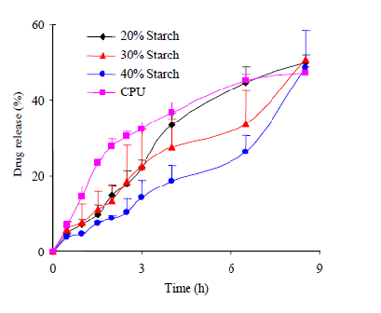

Fig. 1. Effect of tablet geometry on drug release.

A
C
B
D
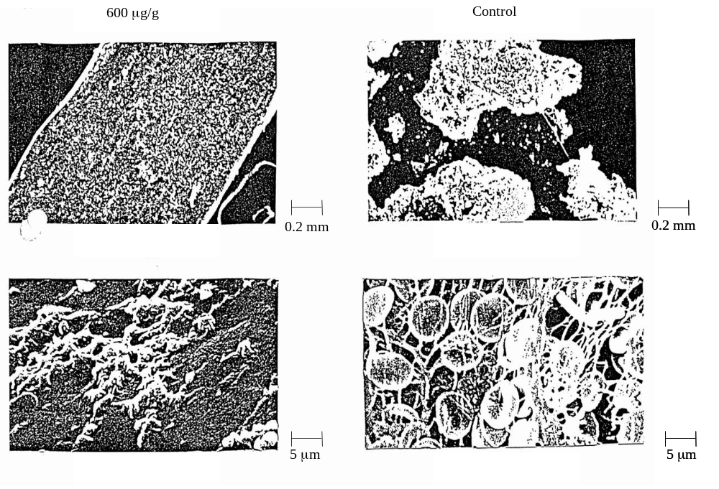

Fig. 2. Pathological features of specimens of the: (A) anterior mediastinum and (B) hepatic tumors demonstrate similar morphology as described in the text. (C, D) he key stains for CD5 were all positive.

Figure samples
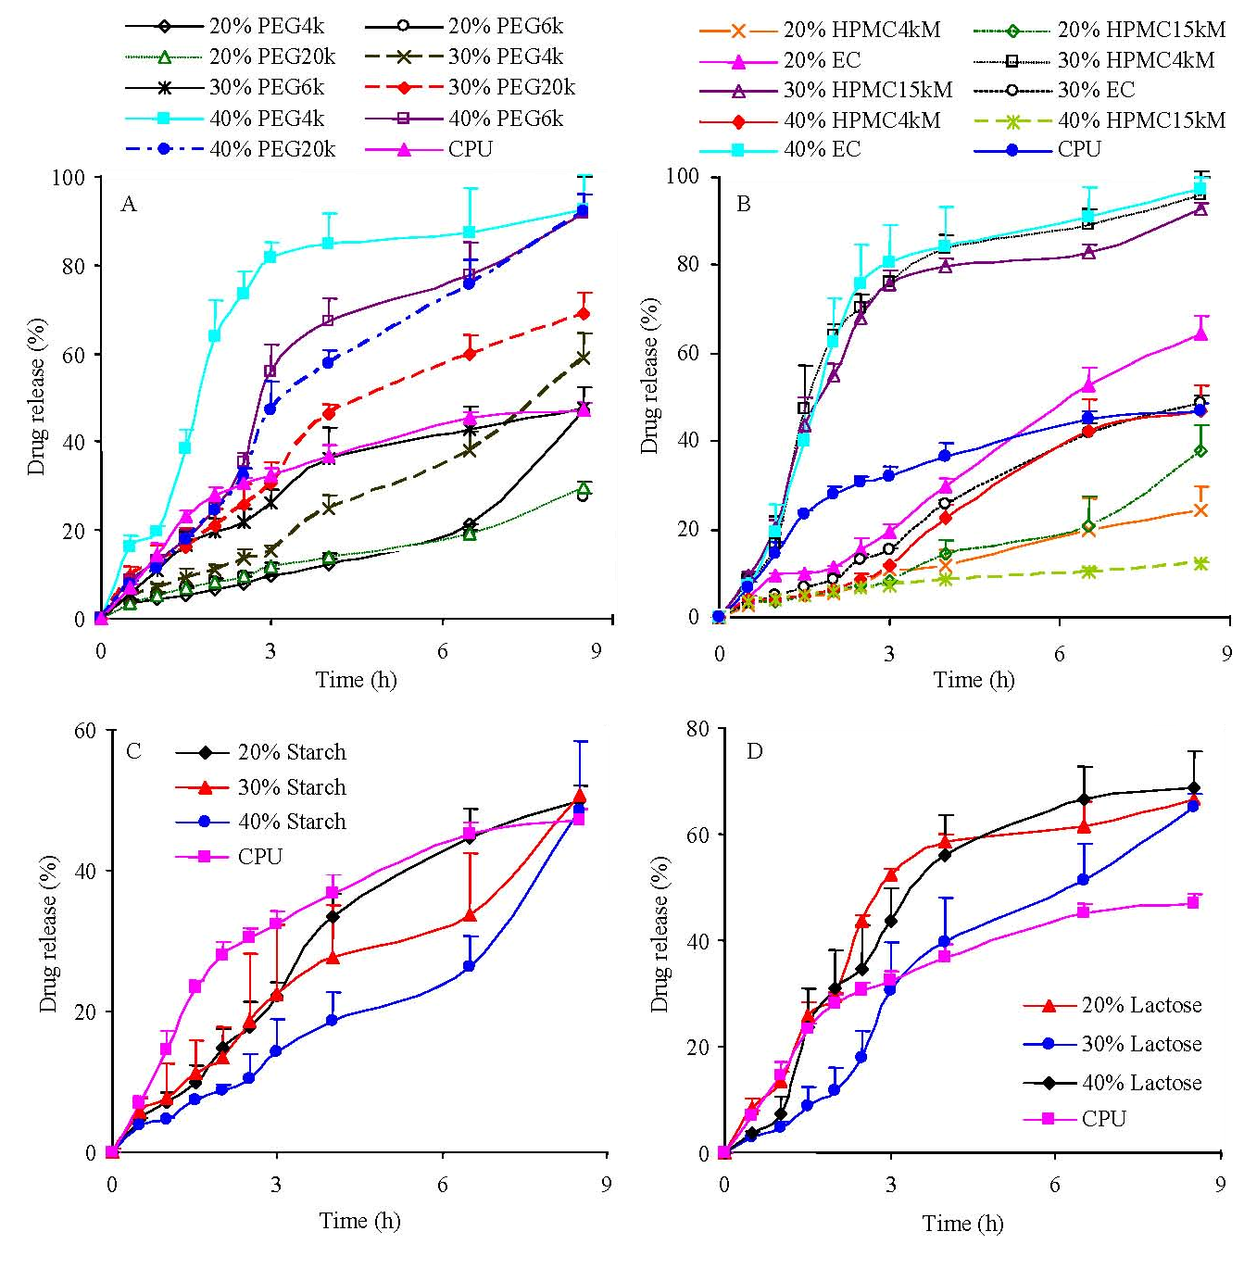

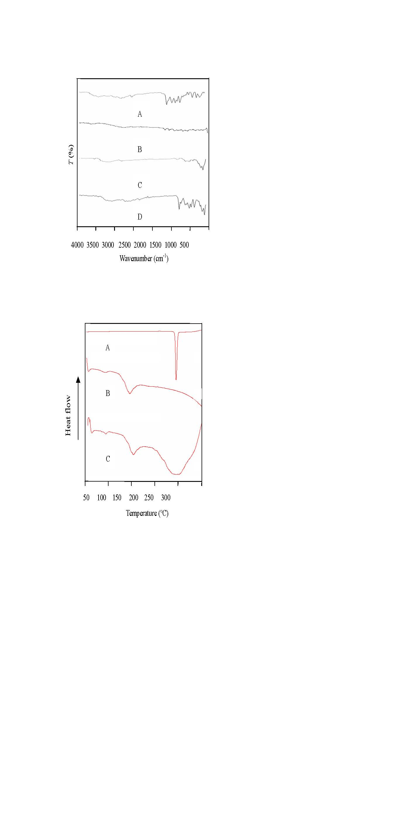

Tables:

Table 1 Pharmacokinetic parameters of nimodipine after oral administrations in dogs
Test preparations | t_{peak}  (h) | C_{max}  (ng/ml) | AUC_{0→∞}  (ng/ml·h) | k_{e}  (h⁻¹) | k_{a}  (h⁻¹)
NimotopTM | 0.58 | 80.29 | 234.70 | 0.376 | 14.832
Immediate release | 0.59 | 70.02 | 277.33 | 0.302 | 5.058
Sustained release | 3.74 | 28.92 | 225.53 | 0.284 | 0.442

